Robust clipped correlation: NZDUSD and USDJPY
Method 04 / daily log returns clipped at ±0.01, ±0.02, ±0.03 / Alpari D1 full available history

Study setup
Logical pair: NZDUSD , USDJPY
Broker symbols: NZDUSD_i , USDJPY_i
Snapshot: 2026-11-03_majors_alpari_D1
Timeframe: D1
Matched return window: 1999-01-05 to 2026-11-02 (UTC bar dates)
Matched return count n: 7185
Dropped unfinished last bar dated 2026-11-03 UTC after a tick-volume check against the prior complete day.
Clip bounds c in log-return units: 0.01, 0.02, 0.03 (about ±1%, ±2%, ±3% on the log scale). Headline c = 0.02.
Clipping caps a day's magnitude at ±c and keeps the row; it does not drop the day, so n is the same at every c.
Complete matched rows (Excel): NZDUSD-USDJPY_Clipped_D1.xlsx
Complete matched rows (HTML table): NZDUSD-USDJPY_Clipped_D1_data.html

Method carried forward
Each matched daily log return of close, ln(close_t / close_t-1), is clipped in the broker quote direction before Pearson correlation: x_tilde = min(c, max(-c, x)) and y_tilde = min(c, max(-c, y)), then rho_clip = Pearson(x_tilde, y_tilde) on the same rows as raw Pearson r. Quotes are not inverted. A day beyond ±c stays in the sample at the cap; n does not change. rho_clip is symmetric under swap of the two symbols. rho_clip = 0 means no straight-line link among the clipped values in this sample; it does not mean no link of any kind. The score is not a cause, not a lead, and not a trading signal. Daily rows are not independent draws, so the two-sided p-value and Fisher interval are reported and treated as secondary to rho_clip. Cap-hit counts (|log return| > c) flag how much of each leg was capped.

Raw Pearson on the same rows
Pearson r: -0.133568
Two-sided p-value: 5.84098e-30
Approximate 95% Fisher interval: [-0.156209, -0.110787]
This is the unclipped comparison required by the method. The headline score is rho_clip at c = 0.02 below.

Clipped results
n = 7185 at every c. Headline row is c = 0.02. Cap-hit count is the number of days with |log return| > c before clipping.
c | rho_clip | p | ci_low | ci_high | rho_minus_r | NZDUSD_cap_hits | USDJPY_cap_hits | NZDUSD_cap_share | USDJPY_cap_share
0.01 | -0.216451 | 6.2063144e-77 | -0.23838151 | -0.19430071 | -0.082882977 | 1105 | 644 | 0.153793 | 0.089631
0.02 | -0.179453 | 4.5901984e-53 | -0.20173872 | -0.15698084 | -0.045884195 | 141 | 75 | 0.019624 | 0.010438
0.03 | -0.155636 | 3.4084853e-40 | -0.17811818 | -0.13299139 | -0.022067539 | 24 | 17 | 0.00334 | 0.002366

Conclusion
Over 7185 matched daily log-return rows for NZDUSD and USDJPY (broker quote directions unchanged), headline robust clipped correlation at c=0.02 is -0.1795 (negative, weak straight-line association among clipped values in this sample). Approximate 95% Fisher interval on the clipped series: [-0.2017, -0.1570]. Same-sample raw Pearson r is -0.1336 (rho_clip minus r = -0.0459). Sensitivity across the fixed grid: c=0.01 same sign; c=0.02 same sign; c=0.03 same sign. Two-sided p under the usual independent bivariate-normal model is 4.59e-53; that model does not match linked daily FX returns, so treat p as secondary. This does not establish cause, lead-lag, or a lasting trading rule.

What to look at in this file next time
1) rho_clip at c = 0.02 versus raw Pearson r. 2) Whether c = 0.01 and c = 0.03 keep the same sign as 0.02. 3) Cap-hit counts before treating a large gap as settled. 4) The ±0.02 lines on the returns chart and the clip box on the scatter.

Charts
Daily closes

Daily log returns with +/- 0.02 clip lines
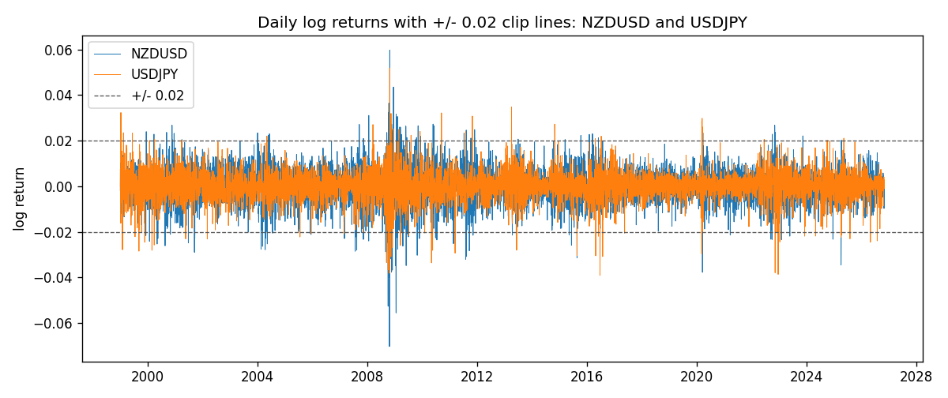
Log-return scatter with +/- 0.02 clip box
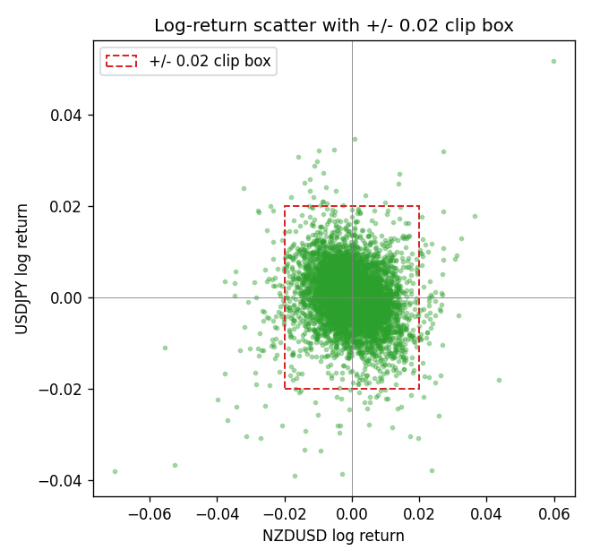

Data report
Every matched row that entered the clipped and raw correlations is stored in the sibling Excel workbook named NZDUSD-USDJPY_Clipped_D1.xlsx. That file is the complete data archive for redrawing charts. Embedding all rows as a Word table is impractical at this length; the Word file holds the column list, column summaries, and the first and last 15 matched rows.
Columns: time, NZDUSD_open, USDJPY_open, NZDUSD_high, USDJPY_high, NZDUSD_low, USDJPY_low, NZDUSD_close, USDJPY_close, NZDUSD_tick_volume, USDJPY_tick_volume, NZDUSD_spread, USDJPY_spread, NZDUSD_real_volume, USDJPY_real_volume, NZDUSD_log_return, USDJPY_log_return, NZDUSD_log_return_clip_0p01, USDJPY_log_return_clip_0p01, NZDUSD_log_return_clip_0p02, USDJPY_log_return_clip_0p02, NZDUSD_log_return_clip_0p03, USDJPY_log_return_clip_0p03
Column summaries (matched calculation rows)
column | count | mean | std | min | 25% | 50% | 75% | max
NZDUSD_open | 7185 | 0.65641035 | 0.10820414 | 0.3913 | 0.59133 | 0.6684 | 0.72491 | 0.88218
USDJPY_open | 7185 | 113.80829 | 19.224285 | 75.693 | 104.39 | 110.98 | 120.695 | 163.824
NZDUSD_high | 7185 | 0.6603272 | 0.1086977 | 0.3961 | 0.59474 | 0.672 | 0.72936 | 0.88421
USDJPY_high | 7185 | 114.30556 | 19.28576 | 76.001 | 104.868 | 111.439 | 121.26 | 163.978
NZDUSD_low | 7185 | 0.65272421 | 0.10779902 | 0.3897 | 0.58806 | 0.66417 | 0.72098 | 0.87988
USDJPY_low | 7185 | 113.28523 | 19.152023 | 75.402 | 103.88 | 110.53 | 120.17 | 163.628
NZDUSD_close | 7185 | 0.65648647 | 0.10820164 | 0.3907 | 0.59157 | 0.6684 | 0.72502 | 0.8822
USDJPY_close | 7185 | 113.8211 | 19.239467 | 75.811 | 104.38 | 111.015 | 120.69 | 163.851
NZDUSD_tick_volume | 7185 | 68717.699 | 123140.61 | 16 | 5585 | 33899 | 58511 | 1127682
USDJPY_tick_volume | 7185 | 106344.18 | 179438.14 | 149 | 9948 | 53202 | 92889 | 1803508
NZDUSD_spread | 7185 | 30.280167 | 25.649381 | 0 | 9 | 17 | 40 | 80
USDJPY_spread | 7185 | 20.273626 | 17.623751 | 0 | 6 | 11 | 30 | 50
NZDUSD_real_volume | 7185 | 1.6703703e+10 | 8.4983725e+10 | 0 | 0 | 0 | 0 | 2.705649e+12
USDJPY_real_volume | 7185 | 3.4781051e+10 | 1.6093614e+11 | 0 | 0 | 0 | 0 | 3.8834203e+12
NZDUSD_log_return | 7185 | 1.284e-05 | 0.0076404 | -0.07027433 | -0.00425236 | 0.00022967 | 0.00458145 | 0.05966839
USDJPY_log_return | 7185 | 4.789e-05 | 0.00620418 | -0.03908203 | -0.00320044 | 0.00011802 | 0.00340223 | 0.05184024
NZDUSD_log_return_clip_0p01 | 7185 | 0.00010419 | 0.00591138 | -0.01 | -0.00425236 | 0.00022967 | 0.00458145 | 0.01
USDJPY_log_return_clip_0p01 | 7185 | 9.107e-05 | 0.00508266 | -0.01 | -0.00320044 | 0.00011802 | 0.00340223 | 0.01
NZDUSD_log_return_clip_0p02 | 7185 | 4.674e-05 | 0.00720052 | -0.02 | -0.00425236 | 0.00022967 | 0.00458145 | 0.02
USDJPY_log_return_clip_0p02 | 7185 | 6.56e-05 | 0.00592897 | -0.02 | -0.00320044 | 0.00011802 | 0.00340223 | 0.02
NZDUSD_log_return_clip_0p03 | 7185 | 2.577e-05 | 0.0074888 | -0.03 | -0.00425236 | 0.00022967 | 0.00458145 | 0.03
USDJPY_log_return_clip_0p03 | 7185 | 5.016e-05 | 0.00613755 | -0.03 | -0.00320044 | 0.00011802 | 0.00340223 | 0.03
First 15 matched rows (selected columns)
time | NZDUSD_close | USDJPY_close | NZDUSD_log_return | USDJPY_log_return | NZDUSD_log_return_clip_0p02 | USDJPY_log_return_clip_0p02
1999-01-05 | 0.5372 | 111.92 | -0.0018597736 | -0.00017868311 | -0.0018597736 | -0.00017868311
1999-01-06 | 0.5383 | 112.77 | 0.0020455609 | 0.0075660159 | 0.0020455609 | 0.0075660159
1999-01-07 | 0.5417 | 111.33 | 0.0062963171 | -0.012851583 | 0.0062963171 | -0.012851583
1999-01-08 | 0.5414 | 110.8 | -0.00055396548 | -0.0047719894 | -0.00055396548 | -0.0047719894
1999-01-11 | 0.547 | 109.02 | 0.010290425 | -0.016195423 | 0.010290425 | -0.016195423
1999-01-12 | 0.5441 | 112.6 | -0.0053157489 | 0.032310364 | -0.0053157489 | 0.02
1999-01-13 | 0.5387 | 113.52 | -0.0099742238 | 0.0081373171 | -0.0099742238 | 0.0081373171
1999-01-14 | 0.5386 | 113.52 | -0.00018564931 | 0 | -0.00018564931 | 0
1999-01-15 | 0.5382 | 114.15 | -0.00074294208 | 0.0055343401 | -0.00074294208 | 0.0055343401
1999-01-18 | 0.5372 | 114.16 | -0.0018597736 | 8.7600193e-05 | -0.0018597736 | 8.7600193e-05
1999-01-19 | 0.5382 | 113.52 | 0.0018597736 | -0.0056219403 | 0.0018597736 | -0.0056219403
1999-01-20 | 0.5404 | 112.91 | 0.0040793678 | -0.0053879917 | 0.0040793678 | -0.0053879917
1999-01-21 | 0.5426 | 113.87 | 0.0040627941 | 0.0084664056 | 0.0040627941 | 0.0084664056
1999-01-22 | 0.5361 | 114.56 | -0.012051689 | 0.0060412564 | -0.012051689 | 0.0060412564
1999-01-25 | 0.5342 | 113.72 | -0.0035504102 | -0.0073594164 | -0.0035504102 | -0.0073594164
Last 15 matched rows (selected columns)
time | NZDUSD_close | USDJPY_close | NZDUSD_log_return | USDJPY_log_return | NZDUSD_log_return_clip_0p02 | USDJPY_log_return_clip_0p02
2026-10-13 | 0.56127 | 158.305 | 0.0047326165 | -0.0018932826 | 0.0047326165 | -0.0018932826
2026-10-14 | 0.55918 | 158.317 | -0.0037306483 | 7.5800166e-05 | -0.0037306483 | 7.5800166e-05
2026-10-15 | 0.56185 | 158.024 | 0.0047634855 | -0.0018524319 | 0.0047634855 | -0.0018524319
2026-10-16 | 0.56509 | 157.964 | 0.0057501001 | -0.00037976126 | 0.0057501001 | -0.00037976126
2026-10-19 | 0.56616 | 158.517 | 0.0018917133 | 0.0034946841 | 0.0018917133 | 0.0034946841
2026-10-20 | 0.56827 | 158.16 | 0.0037199341 | -0.0022546642 | 0.0037199341 | -0.0022546642
2026-10-21 | 0.57003 | 158.108 | 0.0030923331 | -0.00032883504 | 0.0030923331 | -0.00032883504
2026-10-22 | 0.56815 | 156.755 | -0.0033035227 | -0.0085942669 | -0.0033035227 | -0.0085942669
2026-10-23 | 0.56991 | 156.81 | 0.0030929853 | 0.00035080446 | 0.0030929853 | 0.00035080446
2026-10-26 | 0.56826 | 157.458 | -0.0028993932 | 0.0041238746 | -0.0028993932 | 0.0041238746
2026-10-27 | 0.56811 | 157.894 | -0.00026399852 | 0.0027651658 | -0.00026399852 | 0.0027651658
2026-10-28 | 0.56261 | 157.743 | -0.0097283914 | -0.00095679538 | -0.0097283914 | -0.00095679538
2026-10-29 | 0.56296 | 157.683 | 0.00062190714 | -0.00038043789 | 0.00062190714 | -0.00038043789
2026-10-30 | 0.56307 | 157.516 | 0.00019537668 | -0.0010596481 | 0.00019537668 | -0.0010596481
2026-11-02 | 0.56161 | 157.933 | -0.0025962955 | 0.0026438521 | -0.0025962955 | 0.0026438521

